Analysis and Summary  
DAD 220 Intro to Struct Database Environment

Sergio Mateos

Southern New Hampshire University

1. Sales by region.
   1. 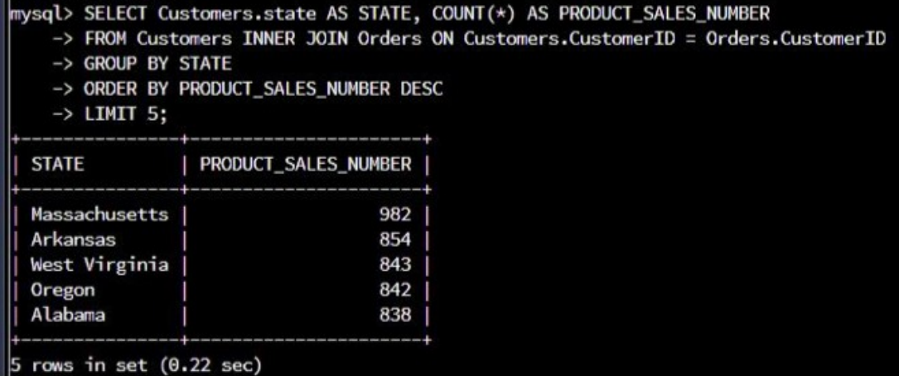Sales data by state to determine where the company has the largest customer base.

SELECT Customers.State AS STATE, COUNT(*) AS PRODUCT_SALES_NUMBER

FROM Customers INNER JOIN Orders ON Customers.CustomerID = Orders.CustomerID

GROUP BY STATE

ORDER BY PRODUCT_SALES_NUMBER DESC

LIMIT 5;

* 1. Text

     Description automatically generatedTop three products sold in the United States.

SELECT COUNT(*) AS PRODUCT_SALES_NUMBER, Orders.SKU AS PRODUCT_SKU,

Orders.Description AS PRODUCT_DESCRIPTION

FROM Orders

GROUP BY PRODUCT_SKU

ORDER BY PRODUCT_SALES_NUMBER DESC

LIMIT 3;

* 1. Graphical user interface, text

     Description automatically generatedTop three products sold in the southeastern region of the United States.

SELECT COUNT(*) AS PRODUCT_SALES_NUMBER,Orders.SKU AS PRODUCT_SKU,

Orders Description AS PRODUCT_DESCRIPTION

FROM Orders INNER JOIN Customers ON Orders.CustomerID =

Customers.CustomerID

WHERE UPPER (State) IN ("VIRGINIA","NORTH CAROLINA","SOUTH CAROLINA","GEORGIA")

GROUP BY PRODUCT_SKU

ORDER BY PRODUCT_SALES_NUMBER DESC

LIMIT 5;

1. Return by region.
   1. Graphical user interface, text

      Description automatically generatedTop three products returned in the United States.

SELECT COUNT(*) AS RETURNED_AMOUNT, Orders.SKU AS PRODUCT_SKU,

Orders.Description AS PRODUCT_DESCRIPTION

FROM Orders INNER JOIN RMA ON Orders.OrderID = RMA.OrderID

WHERE UPPER (Status) = "COMPLETE"

GROUP BY PRODUCT_SKU

ORDER BY PRODUCT_AMOUNT DESC

LIMIT 10;

* 1. Graphical user interface, text

     Description automatically generatedTop three products returned in the northwestern region of the United States.

SELECT COUNT(*) AS RETURNED_AMOUNT, Orders.SKU AS PRODUCT_SKU

Orders.Description AS PRODUCT_DESCRIPTION

FROM Orders INNER JOIN RMA ON Orders.OrderID = RMA.OrderID

INNER JOIN Customers ON Orders.CustomerID = Customers.CustomerID

WHERE UPPER (State) IN ("WASHINGTON","OREGON","IDAHO","MONTANA")

AND UPPER (Status) = "COMPLETE"

GROUP BY PRODUCT_SKU

ORDER BY RETURNED_AMOUNT DESC

LIMIT 10;

1. Report
   1. Part A

The result of the analysis and determine from the data what state will have the most sales, which would be “Massachusetts” with a sales amount of 982. The next states with high sales would be Arkansas, West Virginia, Oregon, and Alabama, with this information we can also focus on pushing sales in these states since we can determine a high demand for our products. The next command provides analyze the three most sold items in the United States which are “Basic Switch 10/100/1000 BaseT 48 port”, “Enterprise Switch 40GigE SFP+ 48 port”, and “Enterprise Switch 10GigE SPF+ 48 port”. This indicates which items would need to be had in stock the most to satisfy customer needs. Southern is an important market so that is why we need to keep up with their needs. The analysis determined that the top three most sold items are “Basic Switch 10/100/1000 BaseT 48 port”, “Enterprise Switch 40GigE SFP+ 48 port”, and "Basic Switch 10/100/1000 BaseT 8 port”.

* 1. Part B

The Region analysis helps us to have more information about the products. The first table provides information about the top three products returned in the United States. The analysis shows the top three products being returned in the United States are “Basic Switch 10/100/1000 BaseT 48 port”, “Enterprise Switch 40GigE SFP+ 48 port”, and “Enterprise Switch 10GigE SFP+ 48 port”. The data help to analyze what product has a higher potential to be returned and also this helps us to make more research about those products. The northwestern region was our next target to analyze what products are returned the most. The data shows that the top three items returned in the Northwestern region are “Basic Switch 10/100/1000 BaseT 48 port”, “Enterprise Switch 40GigE SFP+ 48 port”, and “Enterprise Switch 10GigE SFP+ 48 port”. After analyzing the items, we can determine what items need to be focused on and check for potential failure or any other reason o why customers are returning them.